**Lab Notebook Table of Contents**

|  |  |
| --- | --- |
| **Week 1**: Week of June (5th - 10th June) | Pg. 2 - 3 |
| **Week 2**: Week of June (11th - 17th June) | Pg. 4 - 4 |
| **Week 3**: Week of June (18th - 24th June) | Pg. 5 - 6 |
| **Week 4**: Week of June (25th July - 1st July) | Pg. 7 - 9 |
| **Week 5**: Week of July (2nd July - 8th July) | Pg. 9 - 9 |
| **Week 6**: Week of July (9th July - 15th July) | Pg. 10 - 10 |
| **Week 7**: Week of July (16th - 22nd July) | Pg. 11 - 13 |
| **Week 8**: Week of July (23rd - 29th July) | Pg. 14 - 15 |
| **Week 9**: Week of July (30th July - 5th Aug) | Pg 15 - 15 |
| **Week 10**: Week of July (6th - 11th Aug) | Pg 16 - 16 |

**Week 1: Week of June …**

**7th June, 2017**

* **Made an overview/outline of weekly targets and direction of research with Deandra (0.5 hours)**

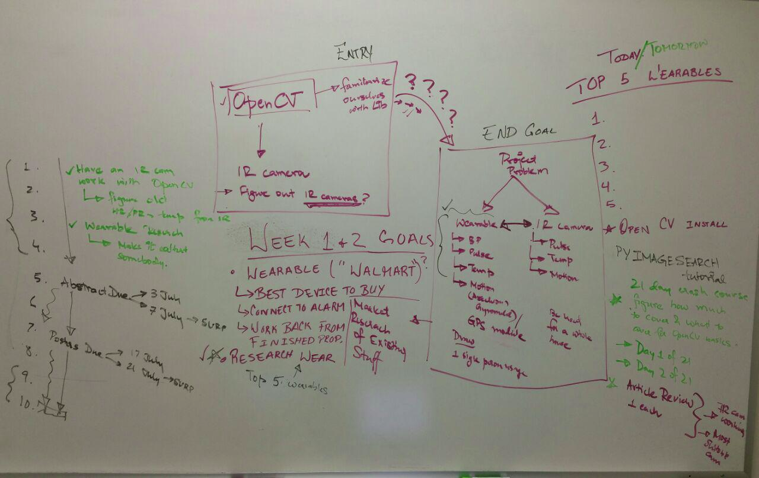

* **Browsing research articles and journals (1 hour)**
* **Multiresolution Approach for Non-Contact Measurements of Arterial Pulse using Thermal Imaging (Reading 1.5 hours)**

[**http://www.cvip.louisville.edu/wwwcvip/research/publications/Pub_Pdf/2006_2/OTCBVS_2006.pdf**](http://www.cvip.louisville.edu/wwwcvip/research/publications/Pub_Pdf/2006_2/OTCBVS_2006.pdf)

* **Set Up OpenCV Libraries on Ubuntu 16.04 (3 hours)**
  + **Began PyImage Search Computer Vision tutorial**
  + **Histogram as feature vectors for image analysis**
  + **Finished Day 1/21 : Image Search Engines**
* **Infrared thermographic camera research… (0.75 hours)**

**Flir :** [**http://www.flir.com/science/display/?id=46623**](http://www.flir.com/science/display/?id=46623)

* **Attempt at headless Rasbian installation on raspberry pi 2 (0.5 hours)**

**8th June, 2017**

* **Learnt command line parsing with Python Argparse library from :**

[**https://docs.python.org/3/howto/argparse.html**](https://docs.python.org/3/howto/argparse.html) **(0.667 hours)**

* **Began reading Chapter 4 : Multi resolution Approach for Noncontact Measurements of Arterial Pulse Using Thermal Imaging (2 hours)**

**Augmented Vision Perception in Infrared - Algorithms and Applied Systems**

[**http://download.springer.com/static/pdf/832/bok%253A978-1-84800-277-7.pdf?originUrl=http%3A%2F%2Flink.springer.com%2Fbook%2F10.1007%2F978-1-84800-277-7&token2=exp=1496949805~acl=%2Fstatic%2Fpdf%2F832%2Fbok%25253A978-1-84800-277-7.pdf%3ForiginUrl%3Dhttp%253A%252F%252Flink.springer.com%252Fbook%252F10.1007%252F978-1-84800-277-7*~hmac=8197908f06989a**](http://download.springer.com/static/pdf/832/bok%253A978-1-84800-277-7.pdf?originUrl=http%3A%2F%2Flink.springer.com%2Fbook%2F10.1007%2F978-1-84800-277-7&token2=exp=1496949805~acl=%2Fstatic%2Fpdf%2F832%2Fbok%25253A978-1-84800-277-7.pdf%3ForiginUrl%3Dhttp%253A%252F%252Flink.springer.com%252Fbook%252F10.1007%252F978-1-84800-277-7*~hmac=8197908f06989a86a304aa55aa2ab2aba72a0a9c1db1b5ead6cc57dea9614172)

[**86a304aa55aa2ab2aba72a0a9c1db1b5ead6cc57dea9614172**](http://download.springer.com/static/pdf/832/bok%253A978-1-84800-277-7.pdf?originUrl=http%3A%2F%2Flink.springer.com%2Fbook%2F10.1007%2F978-1-84800-277-7&token2=exp=1496949805~acl=%2Fstatic%2Fpdf%2F832%2Fbok%25253A978-1-84800-277-7.pdf%3ForiginUrl%3Dhttp%253A%252F%252Flink.springer.com%252Fbook%252F10.1007%252F978-1-84800-277-7*~hmac=8197908f06989a86a304aa55aa2ab2aba72a0a9c1db1b5ead6cc57dea9614172)

* **IR Camera specifications necessary (obtained from Experimental Setup of “Multiresolution Approach for Non-Contact Measurements of Arterial Pulse using Thermal Imaging” ) :**
  + **long-wave Phoenix IR camera from FLIR**
  + **thermal sensitivity of 0.025 oC**
  + **Video frames = 30 frames per second (fps)**

[**http://www.cvip.louisville.edu/wwwcvip/research/publications/Pub_Pdf/2006_2/OTCBVS_2006.pdf**](http://www.cvip.louisville.edu/wwwcvip/research/publications/Pub_Pdf/2006_2/OTCBVS_2006.pdf)

* **Possible options available on the Flir website:**
* [**https://www.ptgrey.com/medical-and-life-sciences-digital-cameras**](https://www.ptgrey.com/medical-and-life-sciences-digital-cameras)
* [**http://www.flir.com/science/display/?id=46623**](http://www.flir.com/science/display/?id=46623)
* **OpenCV Python tutorials from** [**http://docs.opencv.org/3.0-beta/doc/py_tutorials/py_tutorials.html**](http://docs.opencv.org/3.0-beta/doc/py_tutorials/py_tutorials.html)
  + **Completed Introduction to OpenCV**
  + **In GUI Features in OpenCV, completed :**
    - **Getting started with Images**
    - **Getting started with Videos**

**12th June, 2017**

* **Streaming IP network camera over an ethernet connection with python and OpenCV (3 hours)**
  + **Model: Amcrest Pro HD 1080p**
* **Revision of basics of Numpy (1 hour)**

**13th June, 2017**

* **Tau 2 LWIR Thermal Imaging Camera**

[**http://www.flir.com/cores/display/?id=54717**](http://www.flir.com/cores/display/?id=54717)

**14th June, 2017**

* **Network IP camera streaming with Amcrest 1080p over LAN**

**15th June, 2017**

* **Face Recognition using Python and OpenCV**

[**http://hanzratech.in/2015/02/03/face-recognition-using-opencv.html**](http://hanzratech.in/2015/02/03/face-recognition-using-opencv.html)

* **Reading on Haar Cascades**

**Week 3: Week of June …**

**19th June, 2017 (Monday)**

* Began Udemy course :

“Introduction to OpenCV” on Udemy (<https://www.udemy.com/master-computer-vision-with-opencv-in-python/learn/v4/overview>)

* Completed Image Manipulations section:
  + Image Translations
  + Image Rotatiosn
  + Image Pyramids
  + Cropping
  + Blurring
  + Sharpening
  + Thresholding
  + Dilation, Erosion
  + Edge Detection
  + Perspective and Affine Transforms

**20th June, 2017 (Tuesday)**

* Reading and research on IR sensors :
* MLX 90614 : Infrared non-contact Thermometer, arduino compatable

(<https://www.sparkfun.com/products/9570>)

* TMP 36 : Temperature sensor

(<http://www.analog.com/en/products/analog-to-digital-converters/integrated-special-purpose-converters/digital-temperature-sensors/tmp36.html>)

* TMP 007 : IR temperature sensor

**21st June, 2017 (Wednesday)**

* Completed Image Segmentation section:
  + Segmentation and Contours
  + SOrting Contours
  + Approximating Contours and finding their Convex Hull
  + Matching Contour shapes
  + Line Detection
  + Edge Detection
  + Blob Detection
  + Counting Circles and Ellipses in an image

(<https://www.udemy.com/master-computer-vision-with-opencv-in-python/>)

**22nd June, 2017 (Thursday)**

* Completed Object Detection:
  + Feature Description Theory
  + Finding Corners
  + SIFT, SURF, FAST, BRIEF, and ORB
  + Histogram of Gradients
* People Face and Car Detection
  + HAAR Cascade Classifiers
  + Face and Eye Detection

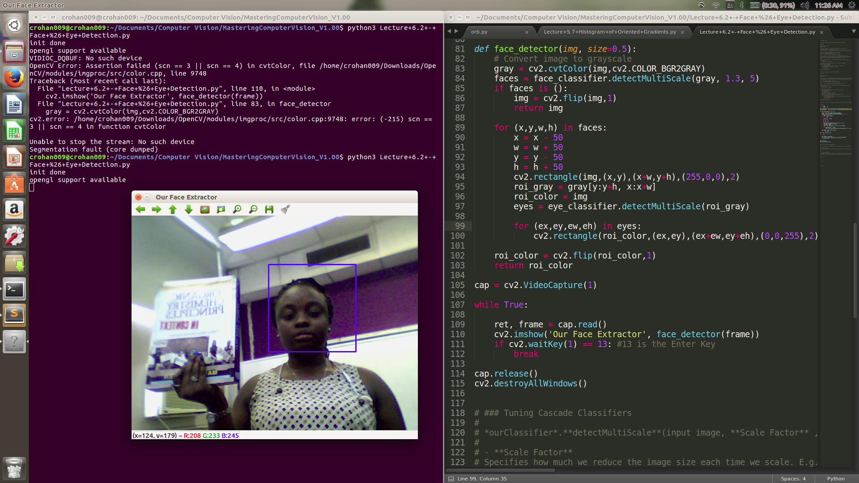

* The picture above uses a HAAR cascade classifier to differentiate between Deandra’s face and an object, and selects the detected face.
* This will be applied to Infrared imagery to select a Region of Interest (ROI) on the face such as the Superficial Temporal Artery (STA) and the Carotid Artery Complex.

**23rd June, 2017 (Friday)**

**Week 4: Week of June …**

**26th June, 2017 (Monday)**

* Diversity in STEM seminar with Prof. Chris Leslie

**27th June, 2017 (Tuesday)**

* Built a prototype robot with raspberry pi

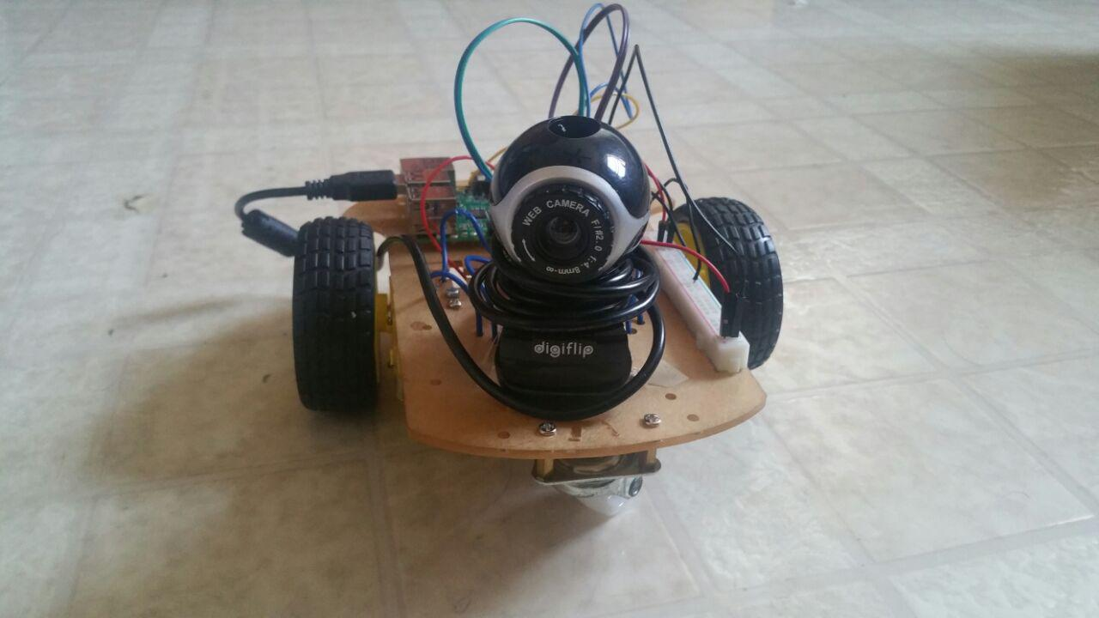

* 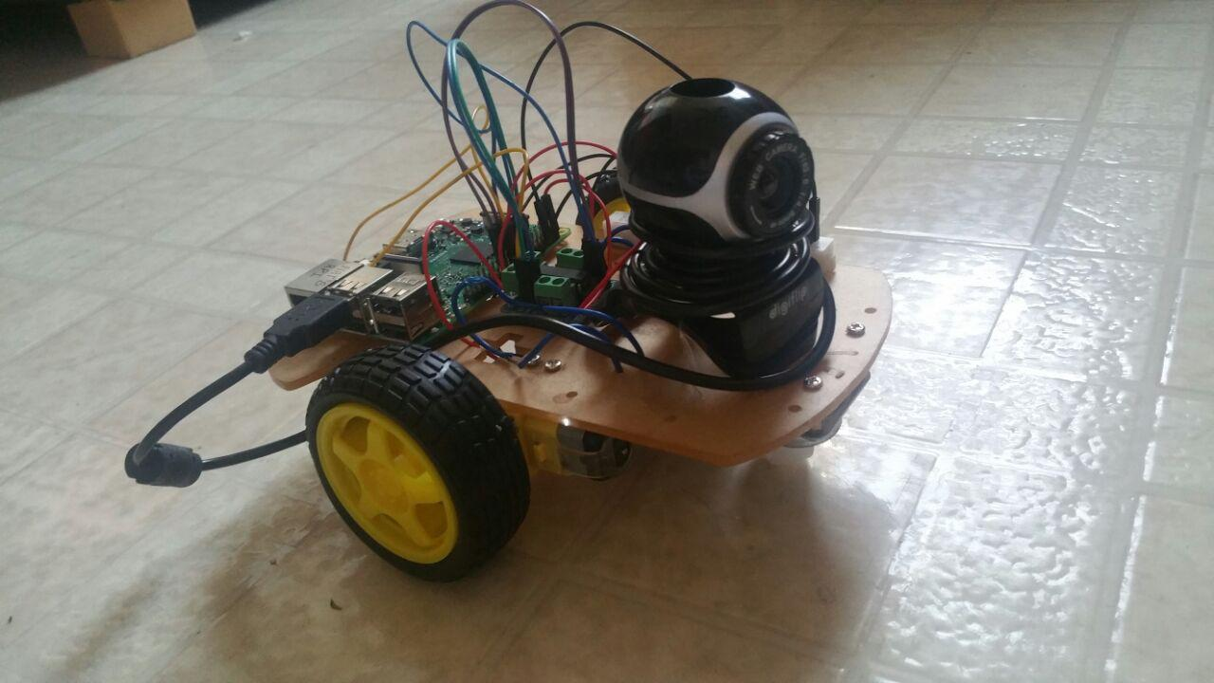
* Interfaced Rpi GPIO pins with L293D and two 9V DC motors

(<https://business.tutsplus.com/tutorials/controlling-dc-motors-using-python-with-a-raspberry-pi--cms-20051>)

**28th June, 2017 (Wednesday)**

* Followed the OpenCV installation guide for Raspberry pi from pyimagesearch.com

(<http://www.pyimagesearch.com/2016/04/18/install-guide-raspberry-pi-3-raspbian-jessie-opencv-3/>)

* Ran into dependency issues
* Tried the following :

(<http://www.instructables.com/id/RasPi-OpenCV-Face-Tracking/>)

* Repeated compilation failure due to package dependency issues and makefile mismatches

**29th June, 2017 (Thursday)**

* Successfully installed OpenCV Raspberry pi
* Installed picamera on Rpi

(<http://www.pyimagesearch.com/2015/03/30/accessing-the-raspberry-pi-camera-with-opencv-and-python/>)

* *Research into integrating USB camera with Rpi …*
* Face Recoginition with USB camera:

<https://raspberrypi.stackexchange.com/questions/38821/face-recognition-with-usb-camera>

* OpenCV tutorial: Training your own detector | packtpub.com
  + - <http://coding-robin.de/2013/07/22/train-your-own-opencv-haar-classifier.html>
    - <https://www.youtube.com/watch?v=WEzm7L5zoZE>
* Webcamera with Raspberry pi
  + - <https://raspberrypi.stackexchange.com/questions/32888/can-we-use-usb-webcam-with-picamera>
* Python extension to capture video with video4linux2
  + - <https://github.com/gebart/python-v4l2capture>

<https://www.raspberrypi.org/forums/viewtopic.php?f=63&t=84388>

* V4l2 0.2 (Python bindings for the v4l2 userspace api)
  + - <https://pypi.python.org/pypi/v4l2/0.2>
* *Research into integrating MLX-90614 IR temperature sensor with Rpi*
* <https://github.com/CRImier/python-MLX90614/blob/master/mlx90614.py>
* <http://www.raspberry-projects.com/pi/programming-in-python/i2c-programming-in-python/using-the-i2c-interface-2>
* <https://learn.sparkfun.com/tutorials/raspberry-pi-spi-and-i2c-tutorial>
* *Serial communication with Rpi*
* <http://www.instructables.com/id/Read-and-write-from-serial-port-with-Raspberry-Pi/>

**30th June, 2017 (Friday)**

* ROS Tutorials from <http://wiki.ros.org/ROS/Tutorials/>
  + Finished 1.1.1 - 1.1.4
* Creating Custom HAAR classifiers :

<http://coding-robin.de/2013/07/22/train-your-own-opencv-haar-classifier.html>

**Week 5: Week of July …**

**3rd July, 2017 (Monday)**

* MLX 90614 sensor I2C protocol testing, programming and debugging

**4th July, 2017 (Tuesday)**

* ROS Tutorials from <http://wiki.ros.org/ROS/Tutorials/>
  + Finished 1.1.5 - 1.1.8

**5th July, 2017 (Wednesday)**

* Training a HAAR cascade classifier to recognize and detect a human ear (WIP)
  + <http://coding-robin.de/2013/07/22/train-your-own-opencv-haar-classifier.html>

**6th July, 2017 (Thursday)**

* MLX 90614 sensor testing
* Finalizing the research abstract and submission
* SSH and VNC on raspberry pi

1. <https://stackoverflow.com/questions/16040128/hook-up-raspberry-pi-via-ethernet-to-laptop-without-router>
2. <http://mitchtech.net/vnc-setup-on-raspberry-pi-from-ubuntu/>

**7th July, 2017 (Friday)**

* SLAM reading (Systematic Localization and Mapping)

**Week 6: Week of July …**

**10th July, 2017 (Monday)**

* Finished all “*Core ROS Tutorials*” form - http://wiki.ros.org/ROS/Tutorials
* Artificial Intelligence for Robotics : <https://www.udacity.com/course/artificial-intelligence-for-robotics--cs373>
  + Finished Histogram Filter

**11th July, 2017 (Tuesday)**

* Artificial Intelligence for Robotics : <https://www.udacity.com/course/artificial-intelligence-for-robotics--cs373>
  + Kalman Filter
  + Particle Filter

**12th July, 2017 (Wednesday)**

**13th July, 2017 (Thursday)**

**14th July, 2017 (Friday)**

**Week 7: Week of July …**

**17th July, 2017 (Monday)**

* Article review 7
* Worked on WIP presentation 2

**18th July, 2017 (Tuesday)**

* Familiarised myself with TinkerCAD and Solidworks
* Modified an existing STL file to accommodate a servo motor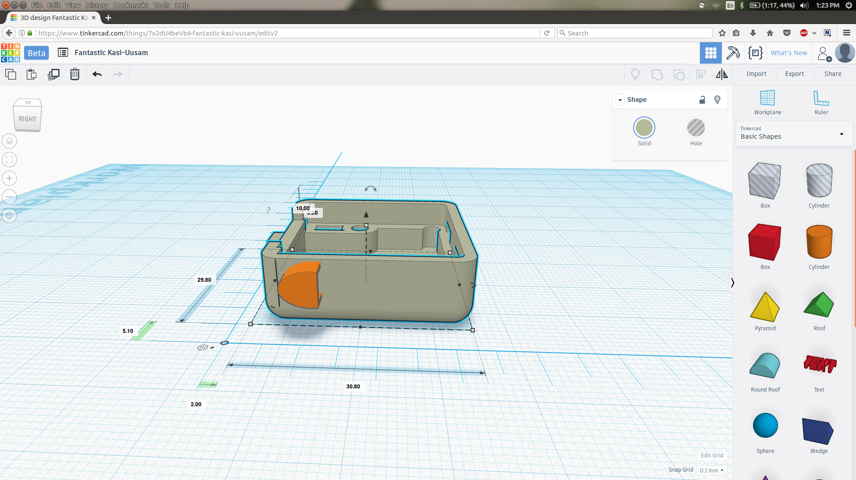

**19th July, 2017 (Wednesday)**

* Article review 8
* Worked on WIP presentation 2

**20th July, 2017 (Thursday)**

* Finished 3D printing and assembly of servo motor camera holder apparatus
* Second WIP presentation
* Prof Lee’s birthday 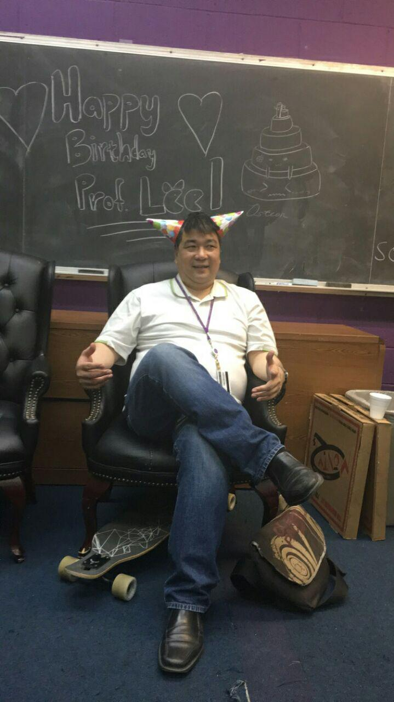

**21st July, 2017 (Friday)**

* Finalised the research poster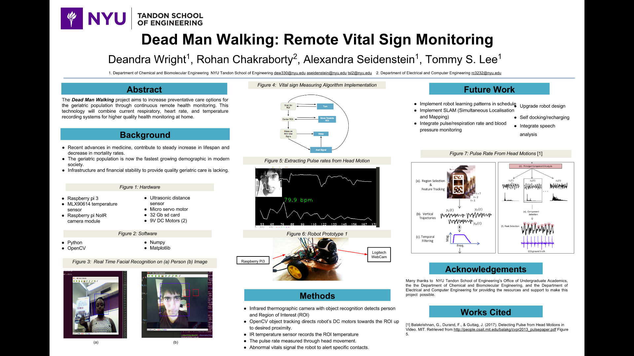

* Learnt how to use the Laser cutter at the Makerspace

**Week 8: Week of July …**

**24th July, 2017 (Monday)**

* Successfully extracted pulse rates from webcam video stream !!!

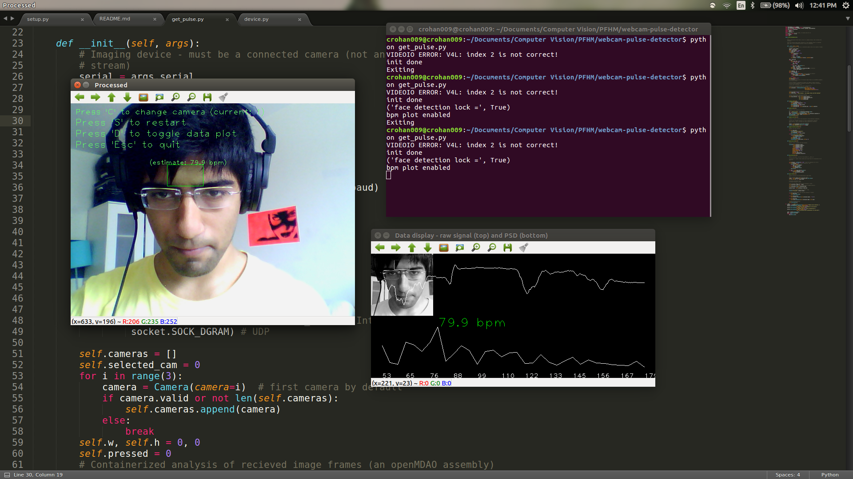

**25th July, 2017 (Tuesday)**

* Machine Learning Stanford University (Coursera) - Week 1 + Week 2

**26th July, 2017 (Wednesday)**

* Machine Learning Stanford University (Coursera) - Week 3

**27th July, 2017 (Thursday)**

* Machine Learning Stanford University (Coursera) - Week 4
* Researched into Logistic regression frameworks for Computer Vision classifiers

<http://www.ritchieng.com/logistic-regression/>

**28th July, 2017 (Friday)**

* PID control - improving the beginner’s PID control algorithm

<http://brettbeauregard.com/blog/2011/04/improving-the-beginners-pid-introduction/>

* Article Review 9
* PID control implementation in Python 2.7

**Week 9: Week of July …**

**31st July, 2017 (Monday)**

* Machine Learning Stanford University (Coursera) - Week 5
* Learnt the basics of Artificial Neural Networks
* Implementing Logical operations with multi-layered ANNs (artificial Neural Networks)

**1st August, 2017 (Tuesday)**

* Testing Pulse from Head Motion on different subjects
* Debugging issues with facial lock and forehead detection for people with a fringe/long hair

**2nd August, 2017 (Wednesday)**

* Installing dlib and scikit-image on raspberry pi
* Debugging issues with swapping space on rpi flash memory

<http://www.pyimagesearch.com/2017/05/01/install-dlib-raspberry-pi/>

**3rd August, 2017 (Thursday)**

* Integrating temperature sensor module into the robot
* Laser cut battery holder platform for DC motor 9V battery pack
* Laser cut battery platform for primary power source (Samsung battery charger)

**4th August, 2017 (Friday)**

* Poster Presentation

**Week 10: Week of July …**

**7th August, 2017 (Monday)**

* Modified Blink detection for rpi compatibility
* Article review 10

**8th August, 2017 (Tuesday)**

* Modified PFHM scripts to run on rpi

**9th August, 2017 (Wednesday)**

* Worked on integrating PID control with servo motor motion